3rd Grade Experiment: How Does ____________________ Affect the Growth of Crystals?

Original (In-School) Experiment | Change You Made
Solute: 2 Tbsp table salt
Solvent: 6 oz. tap water, room temperature
Wick: 30 mm ¼” cotton clothesline, wet

Original setup: Sketch of your setup:
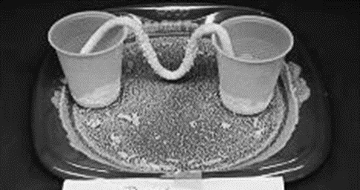

Results:
Crystal size range (estimate):

Shape (sketch):

Location (Where did you find the most crystals?):

Other observations:

